If You Want To Connect Other's Broker

1. Right click on your "Queue Manager" and select "Add Remote Queue Manager".

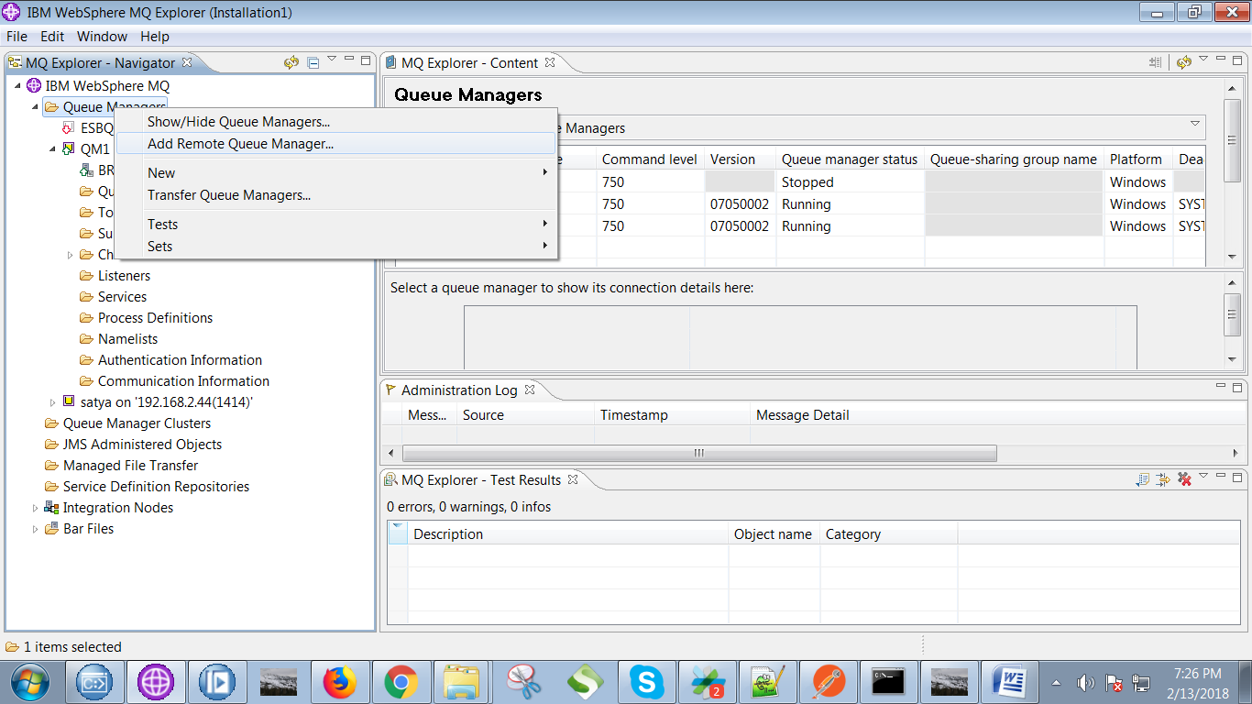

2. Give remote queue name and hit "Next" button.

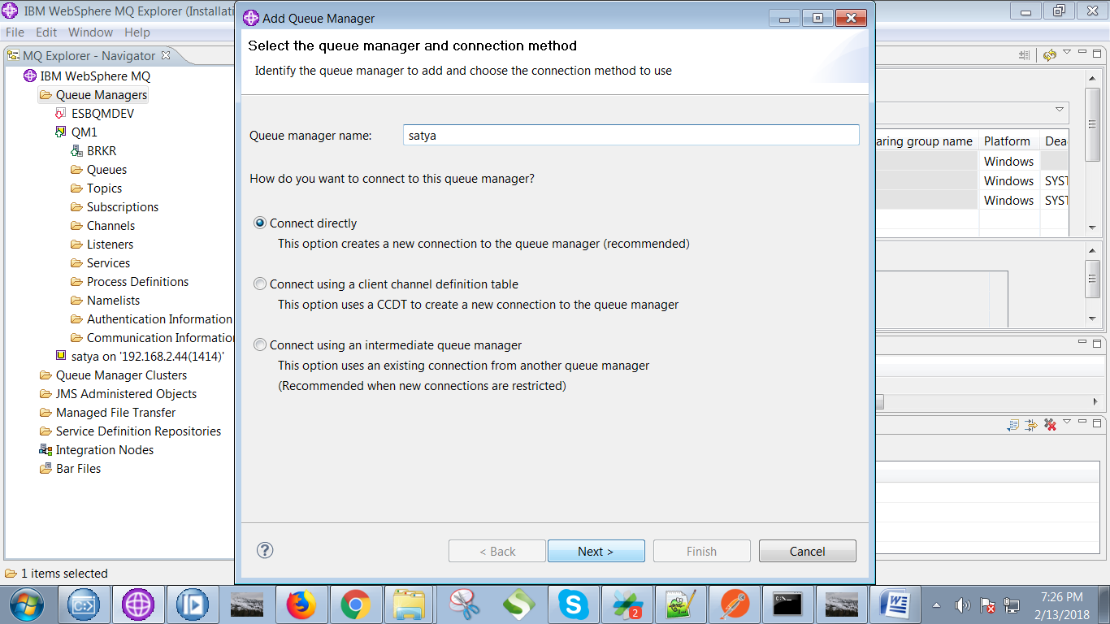

3. Give the remote details(like: host, port channel) as follows and hit "Next" button.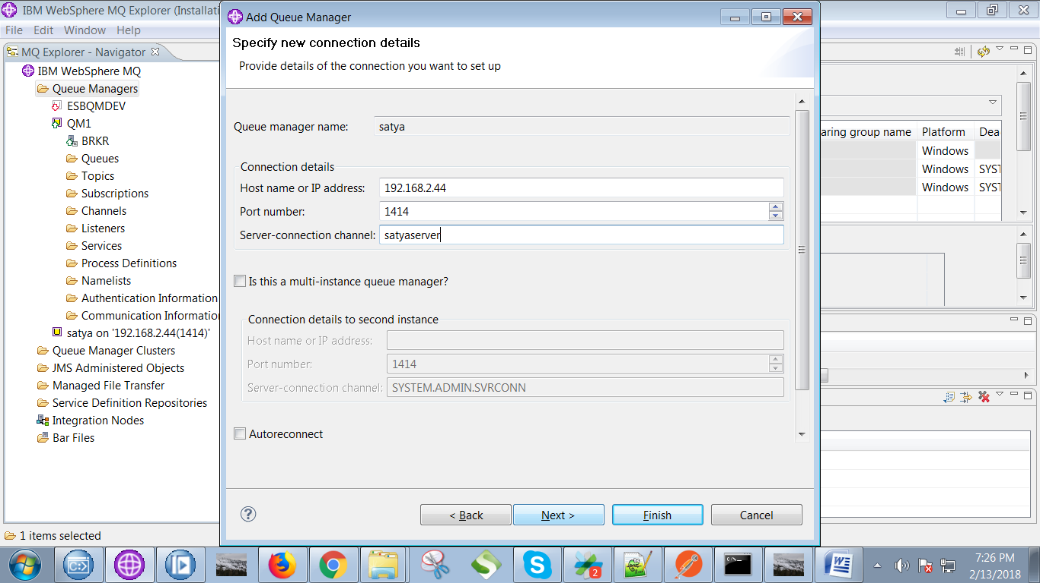

4. For "Enable security exit" don't perform any actions and hit "Next" button.

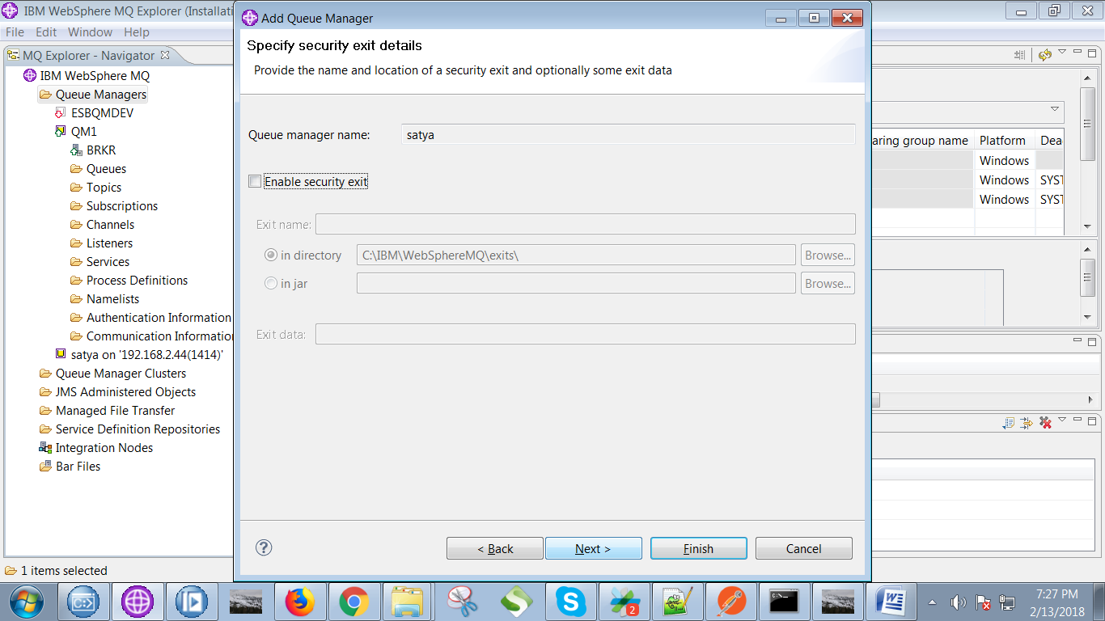

5. For "Enable user identity" type remote system login user name and hit "Next" button.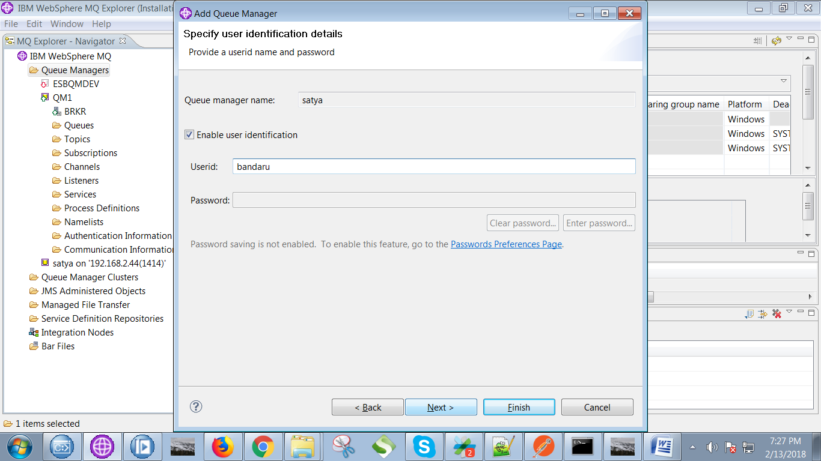

6. For "Enable SSL key repository" don't perform any action, just hit "Next" Button.

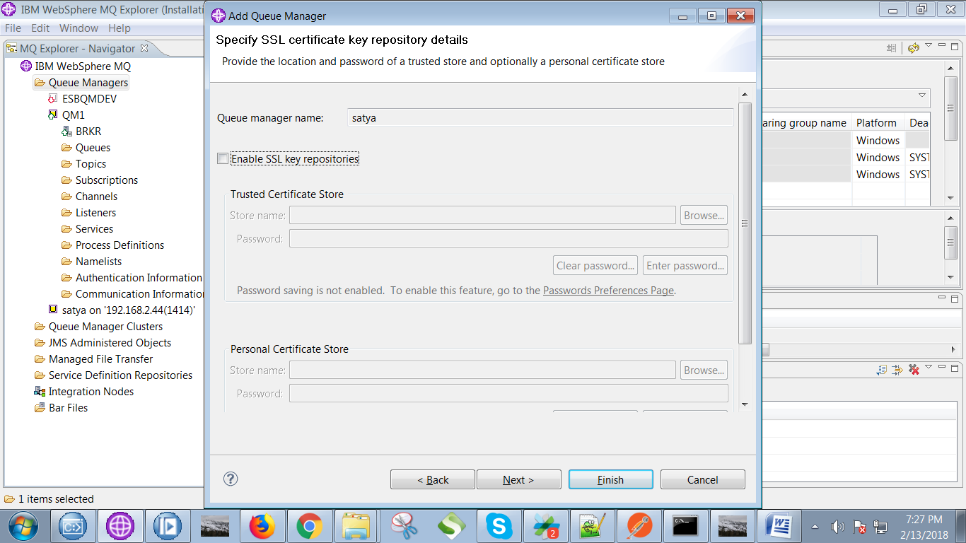

7. For the next tab, don't perform any actions, just hit "Finish" button.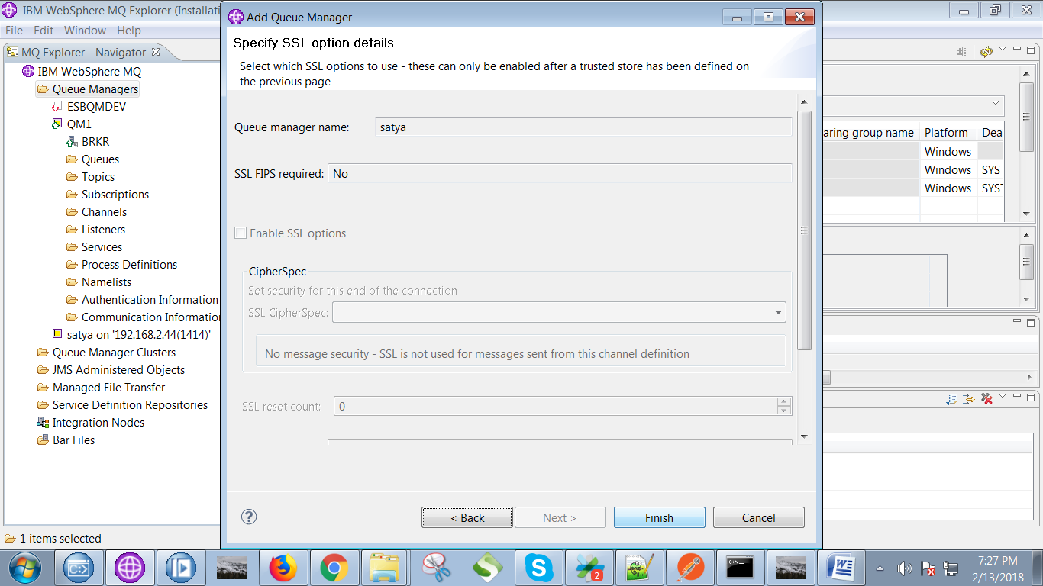

8. Now you able to see remote queue manger(satya) in your "Queue Managers" tab as follows.

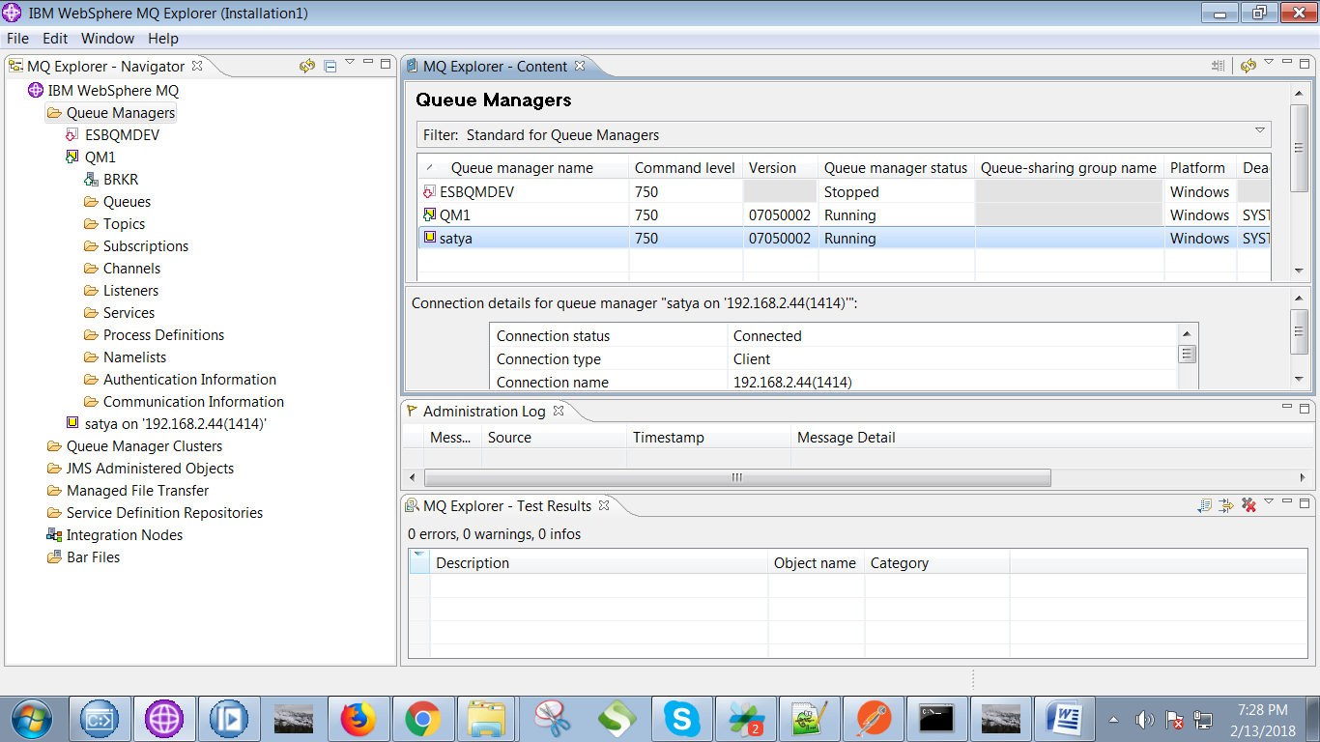

9. Click on windows button and right click on "computers" and select "properties".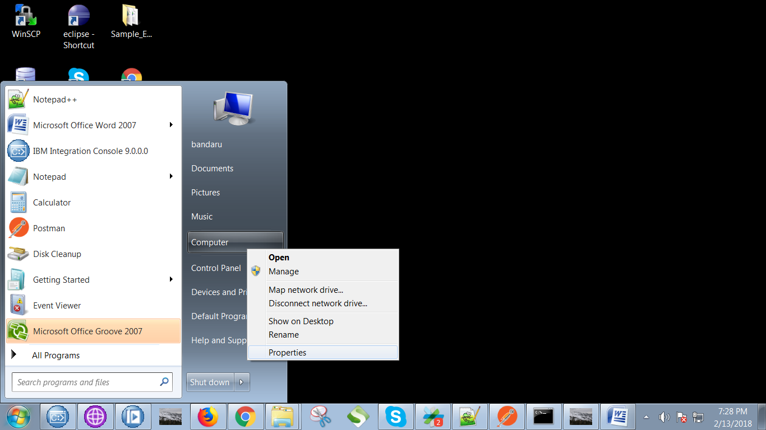

10. Following screen appears, select "Advance system settings".

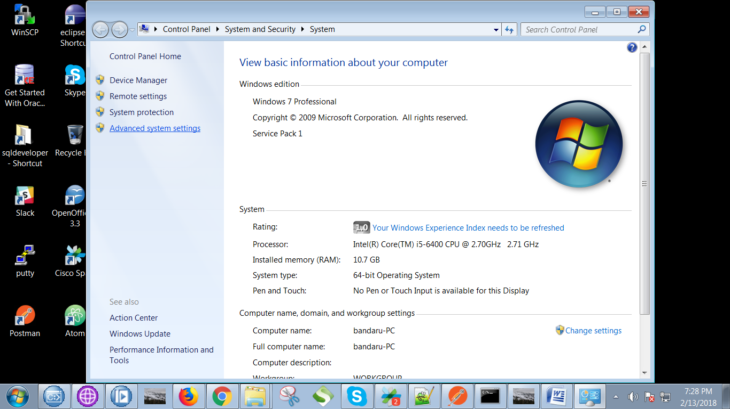

11. Now select "Environment Variables" when following screen appears.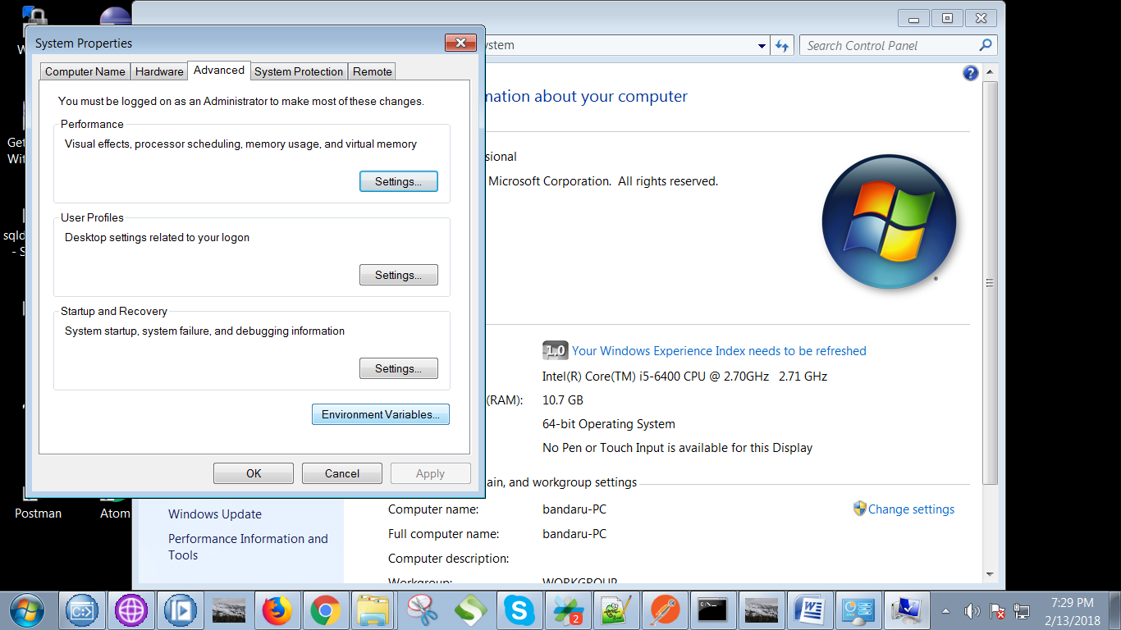

12. Click on "New" button under "System variables" section.

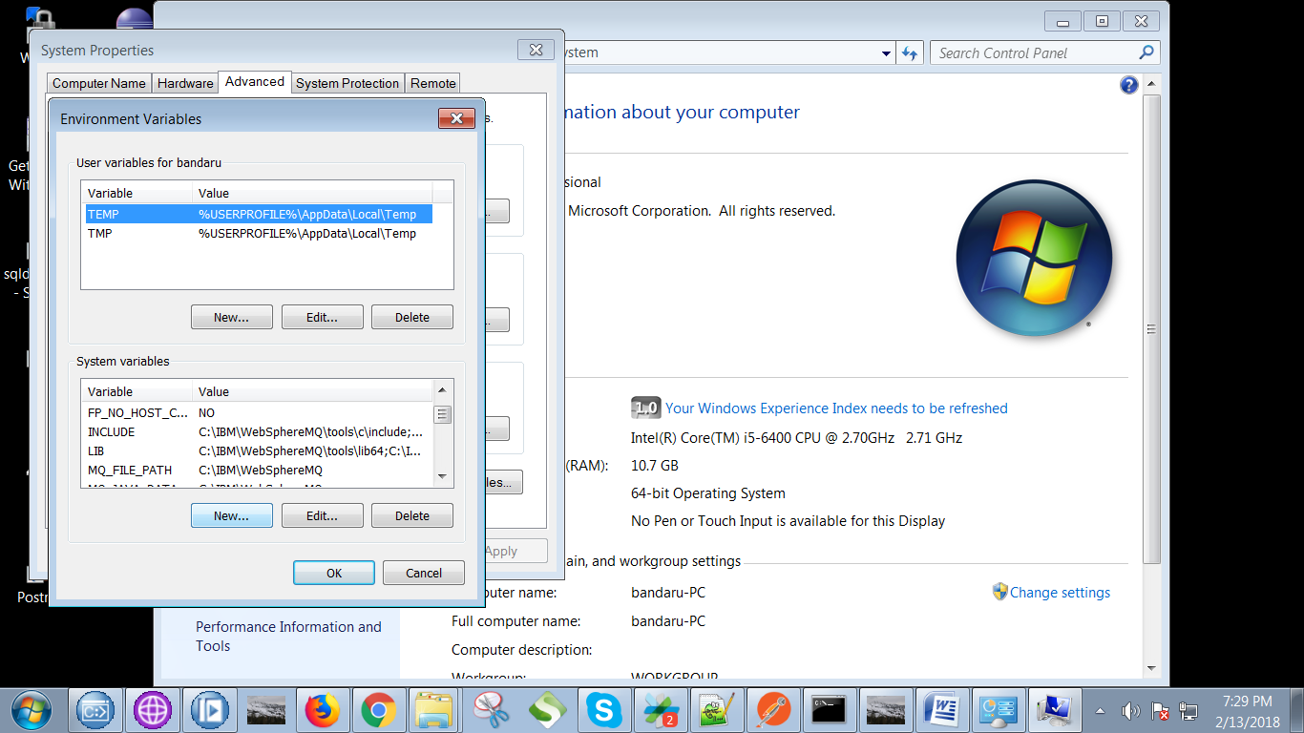

13. Type following remote queue manager details as following.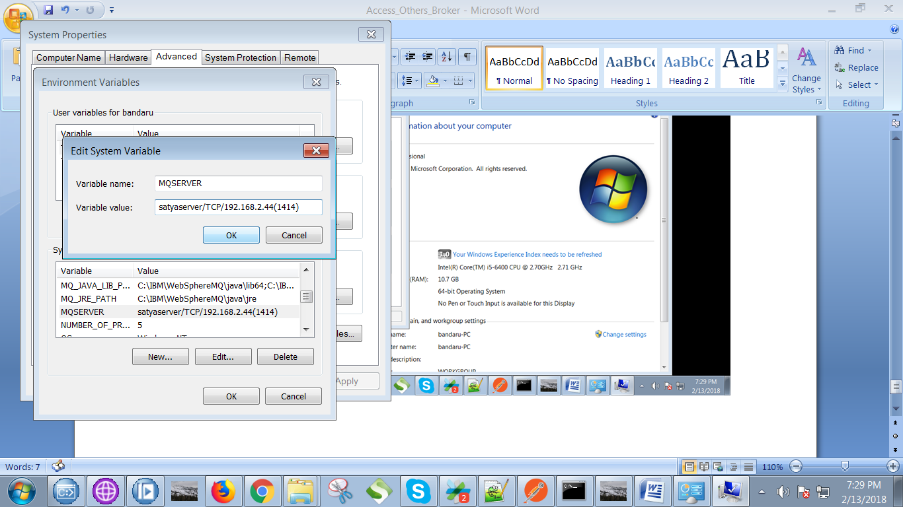

14. Navigate to following location "C:\EidikoTools\ih03" and select "rfhutilc".

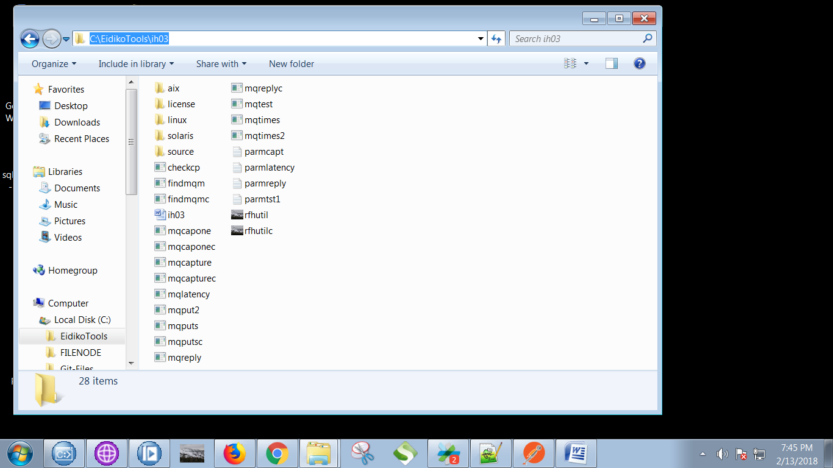

15. Now you able to see your remote queue manager as follows.